Évolutions hydrodynamiques spatiales et temporelles dans l’estuaire de la Van Uc

À partir de campagnes de mesures in situ réalisées pendant la saison humide de l’année 2022 dans l’estuaire de la Van Uc, nous étudions les variations de l’intrusion saline, de la vitesse et de la stratification, à la fois en termes temporels et spatiaux, pour des conditions de vives-eaux similaires. Cette partie explore la dynamique à haute fréquence de l’estuaire de la Van Uc, à partir des données d’ADCP et de CTD. L’estuaire montre une forte sensibilité au débit, un débit important retardant l’inversion des courants à l’embouchure, l’intrusion saline et son extension dans le chenal. L’extension de l’intrusion saline est maximale au début du jusant, et sa position la plus amont a été mesurée à 13 km en amont de l’embouchure pour un débit faible. La répartition verticale alterne entre une colonne d’eau non salée homogène et une colonne stratifiée dont la salinité peut atteindre la surface selon l’endroit dans l’estuaire et les conditions de débit, présentant une structure de vitesse bidirectionnelle durant le flot.

Cette partie confirme à partir des données collectées le rôle primordial du débit dans l’hydrodynamique et sa variabilité de l’estuaire de la Van Uc, y compris dans la gamme de débits échantillonnés ici, situés dans la gamme haute (saison humide). Les mesures in situ effectuées viennent enrichir la base de données très limitée existant sur cet estuaire. Enfin, ces mesures fournissent une précieuse documentation de l’état de la Van Uc à un moment charnière de son évolution, avant que cette rivière déjà anthropisée ne devienne un estuaire portuaire d’envergure internationale.

*Les résultats présentés ici sous la forme d’un article soumis à XXXX ont été présentés à la conférence AGU Ocean Sciences de Février 2024 de La Nouvelle-Orléans (en ligne).*

Hydrodynamical longitudinal and temporal evolutions across the Van Uc estuary, Red River, Viet Nam

Pénicaud J.1, Ouillon S. 1,2, Vinh V. D.3 , Toublanc F.1, Herrmann M.1

1: Université de Toulouse, LEGOS (CNES/CNRS/IRD/UT3), Toulouse, France

2: Department of Water – Environment ‑ Oceanography, University of Science and Technology of Hanoi, Vietnam Academy of Science and Technology, No 18 Hoang Quoc Viet Str, Hanoi 10000, Vietnam

3: Institute of Marine Environment and Resources, VAST, 246 Danang Street, Haiphong City 180000, Vietnam

**Keywords:** Hydrodynamics, ebb delta, flood dominated, tidal propagation, transects, observations, estuary, Vietnam

**Abstract:**

Hydrodynamics of the Van Uc estuary, a distributary of the Red River (Vietnam), is documented here, examining the variability of river discharge and tides on this mesotidal estuary. This study exploits salinity and velocity data collected during field campaigns led in the wet season of 2022 during spring tide. The higher the discharge, the lower the maximum inflow velocity, the longer the bidirectional flow period, and the later salinity entrance. The stratification in the estuary goes from a homogeneous freshwater column to a stratified column during the bidirectional flow during the flood period, and the salt intrusion is maximum during the early ebb phase. During the wet season campaigns, the lowest river discharge conditions lead to a further upstream salt intrusion by 13 km from the mouth. The field survey revealed a very accidented and variable bathymetry, in the meanders of the river and near the coastal zone, confirmed by the satellite delta. The structure is typical of ebb-tidal delta, and its channelized zone downstream the mouth supports a highly moving salt limit.

# Introduction

Estuaries are at the interface of rivers and ocean, conferring them highly complex and dynamic characteristics. They are also major suppliers of sediment, nutrients and contaminants to the open sea (Milliman 1991, Meybeck 1993), with a need for monitoring their interaction between these connected environment. Densely populated (Syvitski et al., 2009) and subject to strong anthropogenic pressures, those fragile socio-ecosystems are key in economy and in food and water supply, with many activities (agriculture, aquaculture, navigation …) depending on water quality and quantity. Estuaries ecosystems can be threatened by salt intrusion, siltation/erosion, or flooding, and therefore require specific understanding despite their complexity and the variability they can undergo under different timescales.

Circulation within the estuary determines water and sediment transport. As estuaries are dynamic systems, they are never in a steady state and several factors can enhance mixing and modify the circulation, thus inducing strong gradients of salinity and suspended sediment, highly variable in time and space. Characterizing the water and sediment dynamics of an estuary and their variability is a key requirement to prevent flooding and understand salt intrusion, erosion and siltation pathways, or propagation of contaminants. The three main factors governing the circulation are river discharge, tides and waves (Dalrymple et al., 1992, Boyd et al., 1992), though bathymetry can play a role. The main driver in each estuary depends on its configuration, and the first step to have a better understanding of a very specific place is to document the contributing factors (river discharge, tide, river morphology) and their interactions within a given estuary.

Tides influence water level, stratification and salt intrusion in the estuary (Savenije, 1994), as well as the sediment transport (Fry and Aubrey, 1990). Tides propagating within the estuary lead to a tidal asymmetry, a significant process that affects sediment transport, in particular in the formation of estuarine turbidity maxima (Allen et al., 1980; Eisma 1993; Vinh and Ouillon, 2021). Variations in river flow also influence the estuarine circulation, either at low frequency (van Maanen and Sottolichio, 2018, and Zhang et al., 2018, at seasonal scale in the Gironde and Yangtze, respectively) or on a short timescale, e.g. during a major rainfall event. Although river discharge is a key parameter, its interaction with tides has only more recently been inferred. Indeed, in front of a variable river flow, tides can adopt a nonstationary behavior (e.g., Kukulka and Jay 2003a,b; Jay et al., 2011, in the low Columbia river; Guo et al., 2015, 2019, in the Yangtze; Xie et al., 2022, in the Qiantang; Cai et al., 2015, in the Pearl river).

The Van Uc estuary is one of the distributaries of the Red River in Vietnam. It is situated in the Red River - Thai Binh system, which is the most densely populated area of Vietnam. A new 20,000 ha harbor project is planned for this area, which will significantly change the configuration and dynamics of the estuary. Despite this, little is known about this estuary: to our knowledge, no field studies were reported in the literature before 2017. Piton et al. (2020) conducted campaigns to analyze the physical variability of water and sediment dynamics and characteristics on a tidal scale at three stations in the estuary during the wet and dry seasons, for neap and spring tides. This paper documented the variations in stratification according to the season, the fortnightly tidal cycle, the tidal phase and the location in the estuary and therefore described for the first time the main features of the dynamics of the Van Uc estuary. The tidal asymmetry in the Van Uc estuary was quantified in a previous work (Pénicaud et al., sub), highlighting a flood-dominance, i.e. a shorter rising tide, stronger for spring tide compared to neap tides, and enhanced by high river discharge, therefore highlighting the major role played by river discharge. Further research is now required to understand its dynamics at higher frequencies, as well as the longitudinal variation of salinity or currents at a finer scale. Processes to be studied include in particular salt intrusion, the evolution of high-frequency stratification and the impact of river discharge on these indicators.

In this framework, the present study completes and extends the analysis of fine-scale high-frequency dynamics and tide-discharge interactions in a tropical estuary dominated by river and tides, the Van Uc river. It is based on in situ data collected in 2022 during three campaigns at spring-tide for different wet-season flows. This study examines three major aspects of estuarine dynamics: (a) the temporal evolution of tidal propagation at the mouth at high frequency during tidal cycles, (b) longitudinal spatial variations in currents, temperature and salinity along the channel at several tidal phases, (c) and the morphological particularity of the Van Uc.

# Studied region

The Red River delta, located in North Vietnam, is the most densely populated region of the country, home to the capital, Hanoi, to Vietnam’s second-largest harbor, Hai Phong, and a vital rice-based food industry (see Fig. 1). This region is very vulnerable to flooding, surges and sea level rise, as most of the delta is less than 10 m above sea level.

With a catchment area of 160 000 km² (Milliman, 1995), it is the main source of freshwater and sediment to the Gulf of Tonkin, with a yearly mean discharge of about 3,500 m³/s and 40 Mt/yr (Vinh et al., 2014). The delta is subject to a tropical monsoon climate, giving two distinct seasons. The wind direction changes from mainly southeastward in the wet summer season (May-October) to northeastward in the dry winter season (December-March). Rainfall is highly seasonal, the wet season accounting for around 90% of the annual rainfall (200 cm/yr) while the dry season is only 8% of the total rainfall. As a consequence, the hydrological regime of the Red River system is also highly seasonal : the wet season is 70% of the 3500 m3/s annual flow (Le et al., 2007; Dang et al., 2010; Vinh et al., 2014).

The Gulf of Tonkin is one of the rare bassin with diurnal meso to macrotidal tides. The Helmholtz resonance in the South China Sea (Zu et al., 2008) and the morphology of the basin lead to the domination of the O1 and K1 diurnal tides (Minh et al., 2014), with highest amplitudes observed in the north (reaching respectively 1 m and 0.9 m, according to the FES2014 atlas).

The Van Uc estuary, located close to Hai Phong, is the third of the nine distributaries of the Red River system in terms of river and sediment discharge, contributing to 14.5% of the delta's total water discharge (i.e 17.5 109 m3 yr-1, Vinh et al., 2014). The tidal range at the Hon Dau tidal gauge station, located 10 km offshore from the Van Uc mouth (see Fig. 1), reaches 4 m during spring tide which classifies this estuary as mesotidal. The estuary, approximately 350-450 meters wide and 10 m-deep for the main center channel, includes meanders. The nearshore part is structured by a main channel lined by tidal sandbanks, and hosting shore fishing activity.

# Method and Materials

## Sampling

Field surveys were carried out in the Van Uc estuary and in the nearshore plume at different stages of the wet season (June, August, October) of 2022, always during spring tides (see the amplitudes in Table 1). Two sampling strategies were used. The first strategy consisted of longitudinal sampling transects of 15 to 20 km long, carried out at different tidal stages along the Van Uc estuary. Stations were spaced by ~ 2 km apart by default, and closer when significant turbidity (indicating the possible presence of an estuary turbidity maximum) or rapid salinity change was observed. Transects lasted around 3 h, were conducted in both directions (upstream to downstream and opposite), and extended from 13 km upstream to 9 km downstream of the mouth. We obtained a total of 13 transects (4 in June, 4 in August, 5 in October), hereafter referred to as TJ, TA and TO and the number of the transects. Stations within each transect are referred to as the first month letter and a number (TJ1 in the first transect of June, composed of the stations J1 J2 J3 etc.).

The second strategy consisted of measurements taken at a fixed station (FSJ, FSA, FSO for Fixed Station Month) near the mouth of the river for 6 h in June (resp. 24 h in August and October), in order to follow the evolution of a fixed part of the estuary over the flood (resp. over the whole tidal cycle). Special care was taken to maintain the location of the first June fixed station, but due to different elements, the August and October stations are located further upstream, by 800 m and 1.6 km respectively.

a)

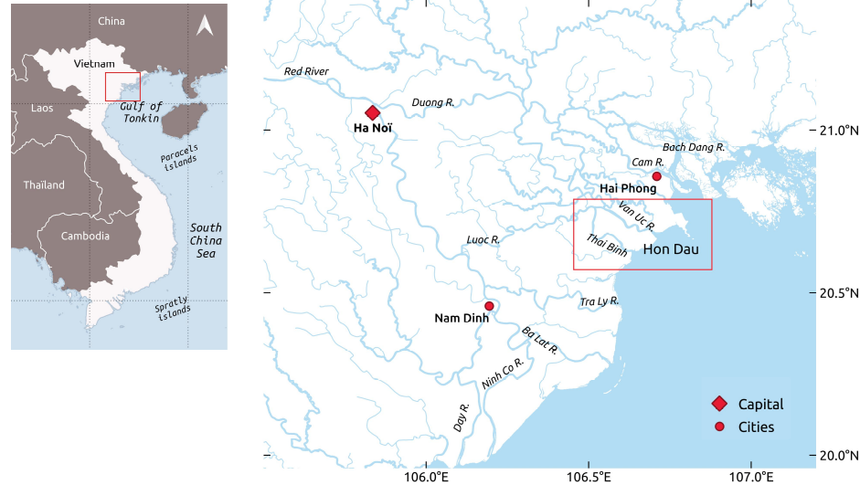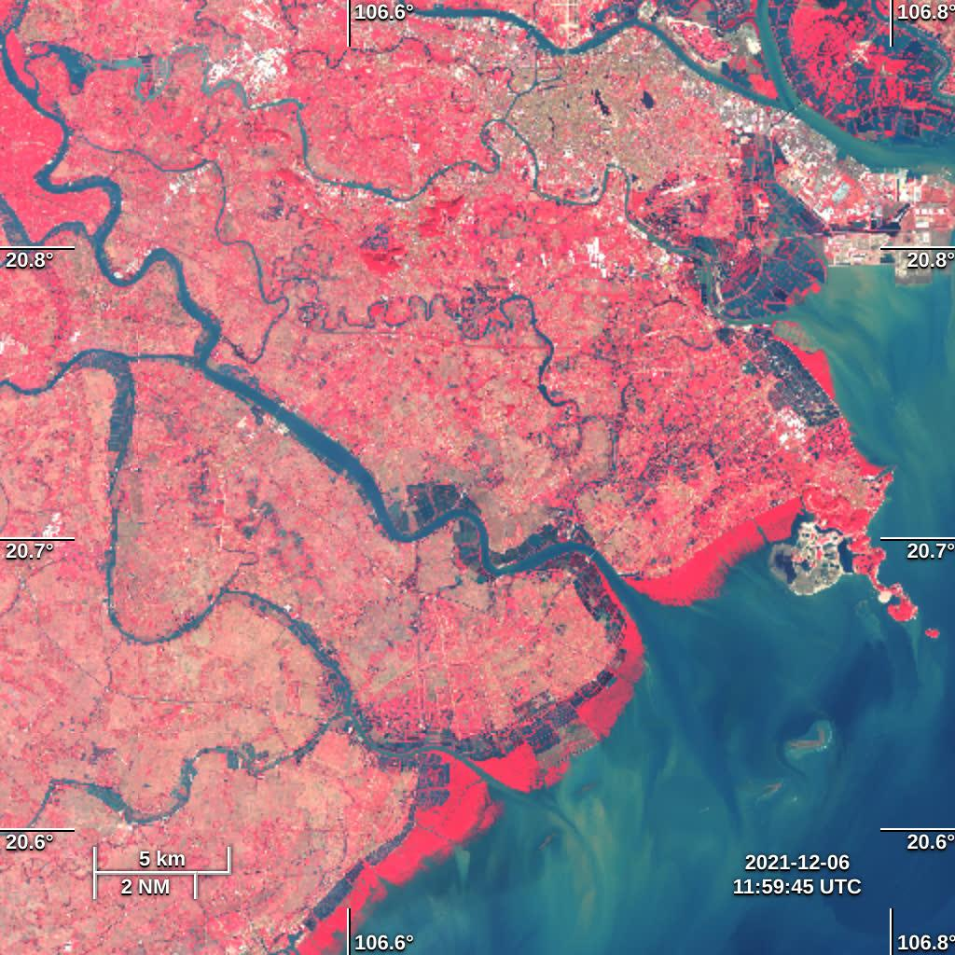

**Trung Trang**

**Van Uc river**

**Luoc river**

**Hai Phong**

**Hon Dau**

**FS**

**limits stations**

**fixed stations (FS)**

**hydrographic**

**stations**

c)

b)

**Thai Binh river**

Figure 1: Vietnam geography (a), the Red River system (b) and the Van Uc estuary (c) with the locations of the two hydrologic stations (triangles) Trung Trang and Hon Dau, of the surveys most upstream and downstream stations (crosses), and of the fixed stations (white line)

During these transects and fixed stations, current velocity was measured continuously with a hull-mounted downward-looking 1200 kHz Acoustic Doppler Current Profiler (ADCP RDI Workhorse in bottom tracking mode). The vertical profile was sampled every 0.3 m (resp. 0.1 m) at a frequency of 1 Hz (resp. 0.2 Hz) during the June (resp. in August and October) survey. At each station, vertical profiles of temperature, salinity, density and turbidity were recorded by a profiling Compact-CTD (ASTD687, Alec Electronics Co., Nishinomiya, Japan, now released by JFE Advantech Co., Nishinomiya, Japan, as Rinko-Profiler). A CastAway-CTD® developed by SonTek was also used to obtain instantaneous profiles and sharpen the transects strategy by better following the real-time evolution of salinity.

Table 1: Transects and fixed stations details (name, date, and number of stations), sampling period, Trung Trang (TT) discharge and Hon Dau (HD) tidal range during the three campaigns. D+1 indicates the end of the fixed stations is at day + 1.

|  |  |  |  |  |  |  |
| --- | --- | --- | --- | --- | --- | --- |
| Month (of 2022) | Transect / Fixed station | Number of stations | Date | Sampling period (T%) | Daily tidal range at HD (m) | Daily discharge at TT (m³/s) |
| June | TJ1 | 10 | 16 | 59 / 88 | 3.8 | 1790 |
| TJ2 | 7 | 92 / -86 | 3.8 |
| TJ3 | 11 | 17 | 44 / 65 | 3.9 | 1736 |
| TJ4 | 11 | -88 / -70 | 3.9 |
| FSJ | 38 | 18 | 45 / 98 | 3.8 | 1954 |
| August | TA1 | 5 | 10 | 75 / 83 | 3.4 | 686 |
| TA2 | 7 | 86 / 95 | 3.4 |
| TA3 | 15 | 11 | 97 / -88 | 3.8 | 929 |
| TA4 | 7 | 12 | 15 / 24 | 3.6 | 1577 |
| FSA | 38 | 12/13 | 13 / 15 (D+1) | 3.6 / 3.4 (D+1) | 1577 / 1867 (D+1) |
| October | TO1 | 7 | 02 | -33 / -26 | 2.6 | 856 |
| TO2 | 14 | 03 | 99 / -85 | 3.0 | 642 |
| TO3 | 9 | -59 / -46 | 3.0 | 642 |
| TO4 | 4 | 04 | 74 / 78 | 3.2 | 691 |
| TO5 | 3 | 04 | 78 / 83 | 3.2 | 691 |
| SFO | 52 | 04/05 | 86 / 83 (D+1) | 3.2 / 3.3 (D+1) | 691 / 613 (D+1) |

## Discharge and Water elevation time series

Hourly water levels measured at the Hon Dau (HD) tidal gauge are used over the two-year period 2021-2022. Hourly discharge data from the Trung Trang (TT) hydrographic station provided by the National Hydro-Meteorological Service (NHMS) are used and averaged to provide daily and monthly means (see their locations on Fig. 1). HD, in the coastal shelf, and TT, upstream in the Van Uc River, are 50 km apart. A second tributary (from the Luoc River) flows downstream of TT, but has no hydrographic station. Therefore, only the discharge at TT was considered for our study.

## Hydrological parameters

### Conventions

In our study, flood (ebb) tide refers to the rising (falling) tide determined at HD.

In order to quantify the position between high and low tide (HT and LT) on the basis of the water level at HD, an indicator called percentage of tide (T%) is created. T% is the ratio of the time elapsed since the previous extreme of tide (HT for ebb tide, LT for flood tide) to the time between the previous and next extremes. 100 T% corresponds to HT and 0 T% to LT, the percentages being positive from LT to HT and negative from HT to LT (Fig. 2). The duration varies from 10 to 13 hours depending on the tidal range.

HT and LT refer to high and low tide at HD. Low and high water (LW and HW) refer to minimum and maximum water levels at other locations. LW and HW slack (LWS and HWS), are periods of practically zero velocity.

Distances are counted negatively for stations located upstream of the reference fixed station (FSJ), positively downstream. Velocity and discharge are negative when the flow enters the estuary from the sea, positive otherwise. Vmin and Vmax are the minimum and maximum velocities, respectively.

Low tide

0 %

High tide

100 %

Mid flood

50 %

Mid ebb

-50 %

Early ebb

-75%

Late ebb

-25%

Late flood

75%

Early flood

25%

Figure 2: Scheme of tide percentages (T%) at HD

### Simpson

The Simpson parameter gives the potential energy anomaly ɸ (J/m³) required to mix the entire column, based on the density (inferred from the CTD measurements):

|  |  |
| --- | --- |
| $ɸ=\frac{1}{H}\int_{−H}^{0}{gz\left(\underline{ρ}−⍴\right)δz}$ | (1) |

with H the water column height, g the acceleration of gravity (m² s-1), z the depth (m) , $\underline{ρ}$ the potential water density averaged over the water column and $⍴$ the water density at depth z. High values (greater than 3 J/m³) correspond to a stratified water column.

### Statistical parameters

The Pearson correlation coefficient (r-value r) is computed to evaluate the linear relationship between two variables. The associated p-value p indicates the level of statistical significance of the correlation: The correlation is considered statistically significant at more than 99% if p< 0.01.

### Data processing

The reference depth is the depth provided by the ADCP measurements. In case the ADCP did not work, the reference depth is the maximum depth of the other instruments.

For Simpson parameter (based on salinity and density), only stations where the CTD covered at least 70% of the reference depth are retained.

For the velocity data, the values are averaged over 1 mn of recording. This corresponds to 60 points for the June survey (1 Hz acquisition frequency) and to 12 points for the other surveys (0.2 Hz frequency).

# Results

## Temporal dynamics

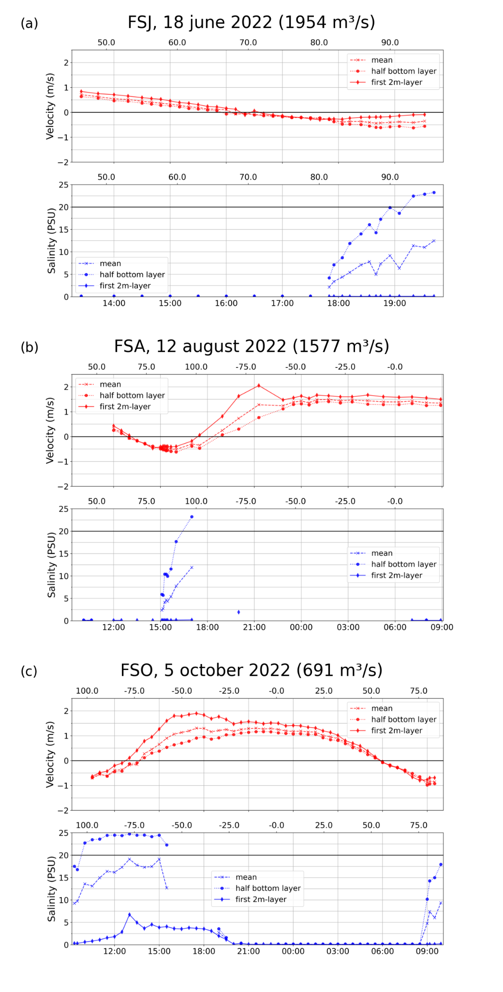

Figure 3: Temporal evolution of velocity (top) and salinity (bottom) for the three fixed stations of June (a), August (b) and October (c), including depth-average values (dashed line), and values averaged over the half bottom layer (dotted line) and the superficial 2m layer (solid line). Lower and upper abscissa indicate the time and the percentage of tide, respectively.

High frequency temporal dynamics of the Van Uc estuary are studied hereafter from three fixed stations located at the estuary mouth in June, August and October 2022. The three different discharge regimes (respectively 1954, 1577 and 691 m3/s, Table 2) allow us to observe the impact of the river discharge on these dynamics. We focus on the velocity evolution, the salinity entrance and the stratification.

### Velocity temporal evolution

The variations of velocity during the three June, August and October fixed stations (FSJ, FSA and FSO) are shown in Fig. 3 (top, positive velocity corresponds to outflow and negative velocity to inflow). We focus here on the moment of current reversal (inflow to outflow and conversely, see Fig. 3). We examine the duration from this moment of zero current to the moment of maximum or minimum velocity, and the corresponding velocity values (Table 2).

**Outflow to inflow reversal**

The reversal from outflow to inflow occurs between mid and late-flood (Fig. 3). It occurs earlier for low than for high discharges, from 55 T% in October (FSO, Q = 691 m³/s, Table 2) to 71 T% in June (FSJ, Q = 1954 m³/s). It happens a few minutes later in the surface layer than in the bottom layer, with a delay that increases with the discharge, from 0 T% in October to 5 T% in June (Table 2). The time between the outflow to inflow reversal and Vmin remains constant over the 3 surveys, ~3h. Consequently, the later the current reversal, the later the maximum inflow: at high discharge (June and August), the maximum inflow occurs close to high tide (94 T% and 92 T% resp) while it occurs at 75 T% in October. The constant Vmin- high water slack (0 velocity corresponding to the current reversal) lag and the Vmax high water lag are coherent with the lags calculated at Trung Trang in Pénicaud et al., (submitted), and shows the same influence of the river discharge getting closer Vmax to the high water.

The maximum inflow velocity value also depends on the discharge: it is higher at low discharge (FSO: -0.98m/s) than at high discharge (-0.62 m/s in FSJ and FSA).

**Inflow to outflow reversal**

The reversal from inflow to outflow occurs during the early ebb phase around high tide. Higher discharge is associated with later current reversal (-99 T% in August vs -80 T% in October, Table 2; the June station was too short to measure it). The reversal occurs first in the surface layer and then in the bottom layer (7 T% lag in August and 11 T% lag in October).

Higher discharge increases the duration between the current reversal and its maximum (32 T% between -99 T% to -67 T% in August, 29 T% between -79 T% to -50 T% in October, Table 2). This behavior is consistent with the values found in previous work where discharge is found to have a significant impact on the high water slack-Vmax lag (Pénicaud et al., submitted). Interestingly, the maximal outflow velocity is similar, no matter the discharge (2.00 m/s for 1577 m³/s in August and 1.90 m/s and 691 m³/s in October, Table 2).

**Duration of the flood and ebb currents**

The duration of the flood-tidal currents (i.e. the landward currents) is shorter than the ebb (seaward) currents. On a two-year period (2021-2022) at the Trung Trang station, the mean duration of ebb-tidal currents is 16h30 and 8h30 for the flood tidal current (Pénicaud et al. submitted). At the fixed stations, the ebb currents, only measured in October, last about 17h (Fig. 3). The flood currents last about 3h in June and ~4h and in August (not measured in October) (Fig. 3), shorter than the mean value at TT. The very high discharge of the June and August fixed stations explain those durations, shorter than the yearly average at TT. As exposed in Pénicaud et al. (submitted), intense river discharge in this tropical estuary can establish a fully ebb-directed currents at Trung Trang. Piton et al. (2020) performed measurements under higher discharge conditions, showing no flood currents at different locations in the estuary. The measurements here show an intermediate situation, with a very short duration of the flood current at the mouth of the estuary, i.e. a strong domination of the river discharge.

At the fixed stations in the Van Uc estuary, the maximum outflow current occurred around mid-ebb for lower discharge, earlier in case of higher water discharge (Fig. 3.b and c), and the peak flood current (Vmin) occurred around late-flood to high tide (closer to high tide in case of high river discharge). This further confirms the mixed behavior of the tidal wave, and its evolution with the discharge, in agreement with the studied lags at Trung Trang (Pénicaud et al. submitted). The sampled fixed stations of August and October show a Vmax (during ebb) superior to Vmin (during flood) (Table 2). However, the discharge sampled here are typical of the high Van Uc river discharge, located in the fourth quartile of discharge (>660 m³/s, based on daily means of the Trung Trang station on the 2021-2022 period), that is to say, a moment at which more water need to outflow the estuary. Therefore, it cannot count for assessing the peak velocity asymmetry, as those situations reflect high discharge conditions.

Table 2: Discharge (m³/s), time of current reversal at the surface and the bottom (in T%), time and value (in m/s) of maximum inflow (Vmin) and outflow (Vmax), time of salinity intrusion and time of maximum salinity (below 0.9 and over 20 PSU respectively) for the three fixed surveys.

|  |  |  |  |  |
| --- | --- | --- | --- | --- |
|  |  | **FSJ** | **FSA** | **FSO** |
| Discharge (m³/s) |  | 1954 | 1577 | 691 |
| Tidal amplitude (m) |  | 3.7 | 3.6 | 3.2 |
| Current reversal  (inflow to outflow) | surface (T%) | Not measured | -99 | -80 |
| bottom (T%) | - | -89 | -72 |
| Vmax | (m/s) | - | 2.00 | 1.90 |
| (T%) | - | -67 | -50 |
| Current reversal  (outflow to inflow) | surface (T%) | 71 | 67 | 55 |
| bottom (T%) | 66 | 64 | 55 |
| Vmin | (m/s) | -0.62 | -0.62 | -0.98 |
| T% | 94 | 92 | 75 |
| Salinity intrusion | T% | 80 | 80 | 76 |
| Salinity (20 PSU) | T% | 92 | 93 | 97 (1st cycle)  ~90 (2d cycle) |

### Salinity temporal evolution

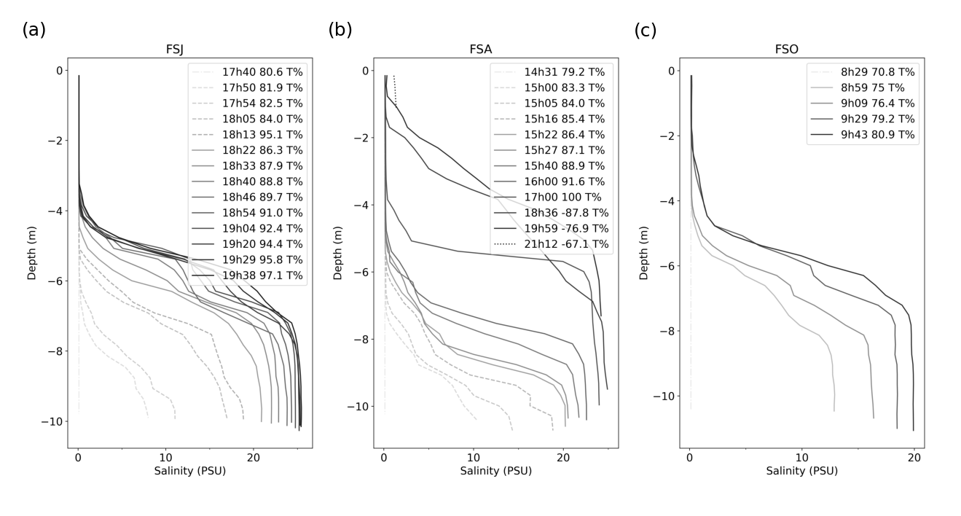

Figure 4: Temporal evolution of salinity profile at the fixed stations in a) June, b) August, c) October 2022. Dash-dot lines highlight the homogeneous water column phase, dashed lines the two layers structure, solid lines the presence of three layers and dot lines the well mixed conditions.

To quantify and understand the dynamics of seawater inflow and outflow, the high frequency salinity profiles recorded at fixed stations is used to determine the time at which the seawater enters or leaves the estuary (taking a criterion of 0.9 PSU) (see Fig. 3,4 and Table 2).

Seawater always starts to enter the estuary in the bottom layer at late flood, up to a maximum salinity around 24-25 PSU. A higher discharge seems to slightly delay the salinity entrance (Table 3): seawater enters at around 80 T% in June and August and 76 T% in October. However, the significance of this result, based on only 3 measurements, cannot be assessed, also knowing the location of the fixed stations is not rigorously the same.

The duration of the transition from 0 to 20 PSU quantifies the speed of the salinity entrance. A higher discharge accelerates the salinity intrusion, and tends to tighten the salt front: this duration is similar in June and August (42 mn and 46 mn respectively), and higher in October (1h25).

The salinity entrance is a quick process, with a salinity going from 0 (over the column) to 7 PSU (in the bottom layer) in 10 minutes, and to 15 PSU in 25 minutes for the June station (Fig. 3a). The seawater flushing is a much slower dilution process and has only been (partially) sampled in October. The return of a homogeneous 0 PSU water column during the ebb phase takes about 5h30, from the maximum salinity (~-63 T%) to 0 PSU (-25 T%, Figure 5.c).

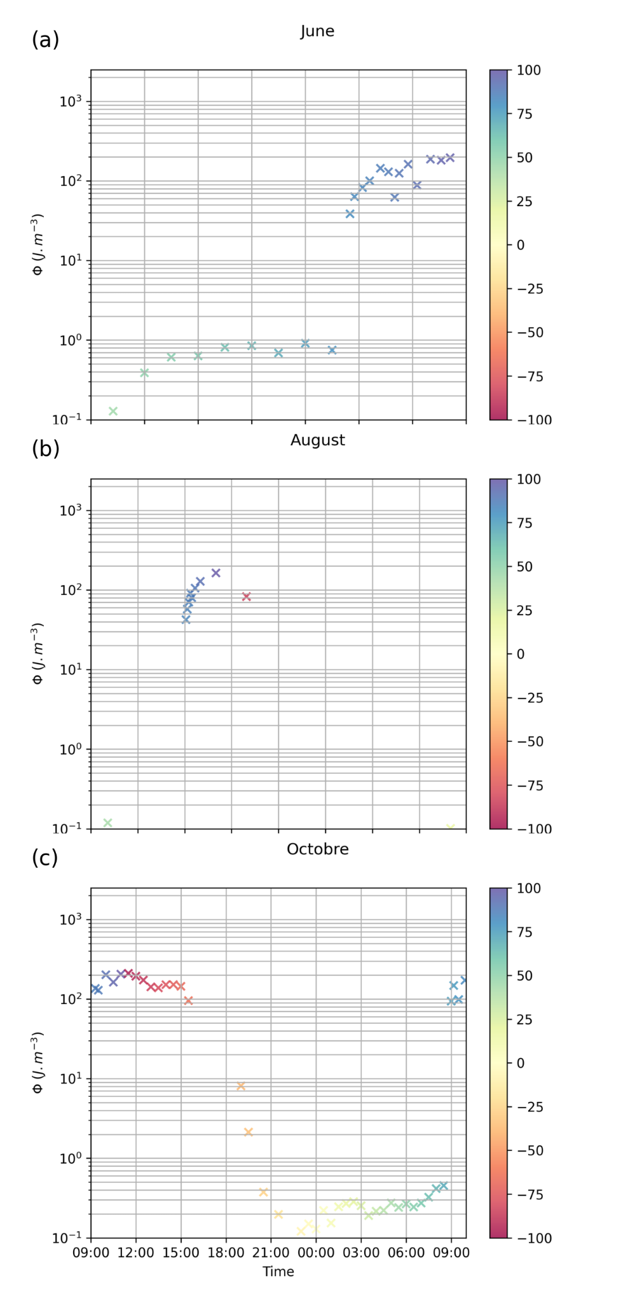

Figure 5: Simpson parameter time evolution over the tidal cycle at the fixed stations of June (a), August (b) and October (c) and thFeir corresponding percentage of tide (T%, colors).

### Stratification

The evolution of water column stratification is described based on the Simpson parameter (Fig. 5) and the salinity vertical structure (Fig. 4). The three surveys follow the same evolution, but the timing differs, presumably due to the difference of discharge (see previous section).

**Simpson parameter values**

The three fixed stations contain both homogeneous and stratified water columns. The Simpson parameter value is between 2x10-¹ J/m³ (homogeneous) and 2.5x10² J/m³ (stratified). The transition between a mixed (<1 J/m³) and stratified column (>100 J/m³) is abrupt, including few medium values (~10 J/m³). In the wet season, the stratification is null during the early flood, and starts at late flood, after 75 T% (see Fig. 5), together with the salinity entrance. Stratification is maximum around high tide. Then, the stratification decreases during the ebb phase, reaching the minimum at the end of ebb phase (see Fig. 4.c).

**Salinity**

The structure of the salinity vertical profile evolves over time following 4 phases (Fig. 4).

The first phase corresponds to a fully homogeneous freshwater column in late flood (dash-dot line in Fig. 4, at 82 T% in June, 79 T% in August and 71 T% in October).

During the second phase (dashed line), we observe two different water masses: a homogeneous freshwater surface layer flows over a bottom salty layer where salinity increases with depth. This second phase was observed in August, between 83 T% and 85 T% (late flood). During this phase, the transition between freshwater and salted water shallows (from -7m to -6.5m for FSA) and the bottom salinity increases (from 10 to 19 PSU).

In the third phase (solid line), 3 distinct layers appear. A homogeneous fresh surface layer, a homogeneous salted bottom layer, and an interface layer with salinity increasing with depth (e.g., during FSA, from 86 T% to -77 T%, i.e. before and after high tide, see Fig. 4.b). This phase is very dynamic and each layer thickness changes. The surface layer reduces with time (FSA: from 6m to 4m deep). The bottom layer thickness expands (from 2 m to 6 m thick at FSA), with a homogeneous salinity that increases (until 24 PSU at FSA). The intermediate (or interface) layer first becomes thinner during late flood (FSA: from 3 to 1 m between 86 T% to 100 T%; the data of June and October surveys end during this phase). It then becomes thicker until reaching the near surface, occupying more than half of the water column at early ebb (only in FSA, at -88 T% and -77 T%, Fig. 4.b).

The last phase during early ebb (only partially sampled in FSA at -67 T%, dot line) corresponds to well mixed conditions: the whole water column is saline (1 PSU at the surface).

At the mouth, the out- to inflow reversal occurs between mid and late flood and the in- to outflow reversal occurs during the early ebb phase. Both reversals occur later for higher discharge. The duration of flood currents is much shorter than the duration of the ebb-currents, which is consistent with a flood-dominance, and probably intensified in the present case of strong discharge. The salinity entrance is a quick process, occurring in the late flood, whose bottom layer salinity maximum is reached close to high tide. The bottom salty layer thickens and can reach the surface, then slowly returns to homogeneous fresh water until late ebb. The stratification, in link with salinity, evolves from homogeneous freshwater (from late ebb to mid-flood) to a partially mixed water column (during the time salinity reaches the surface at early ebb), passing by stratified waters in between (late flood).

## Spatial dynamics

This section illustrates the stratification, the salt intrusion and the velocity along the estuary for different discharge and tidal cycle conditions, based on measurements along the longitudinal transects.

### Stratification

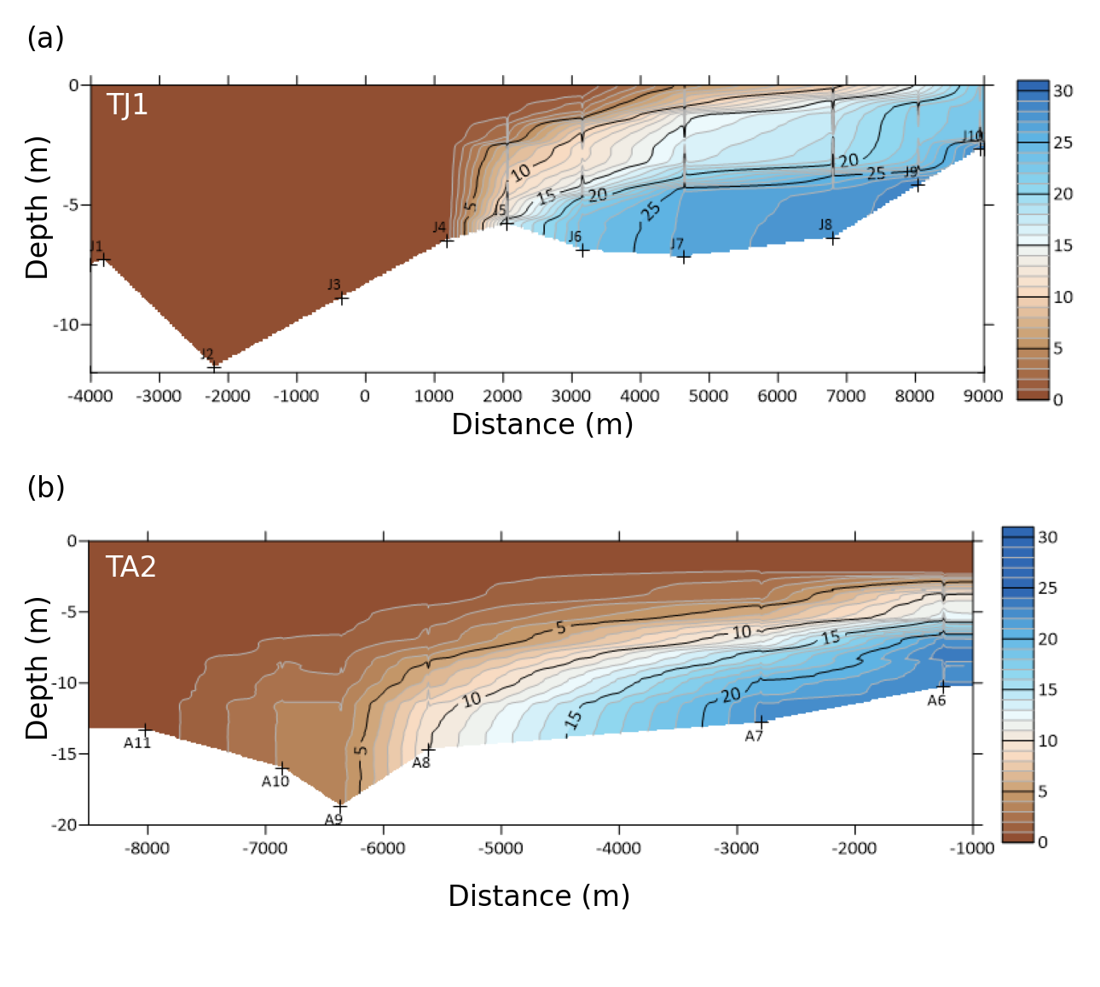

Figure 6: Vertical and longitudinal variations of salinity at a) TJ1 (1st transect of the June survey) on 16 june 2022 from mid to late flood (59 to 88 T%) for a daily discharge of 1790 m³/s and b) TA2 (2nd transect of the August survey) on 10 august 2022 at late flood (85.7 to 94.5 T%) for a daily discharge of 687 m³/s.

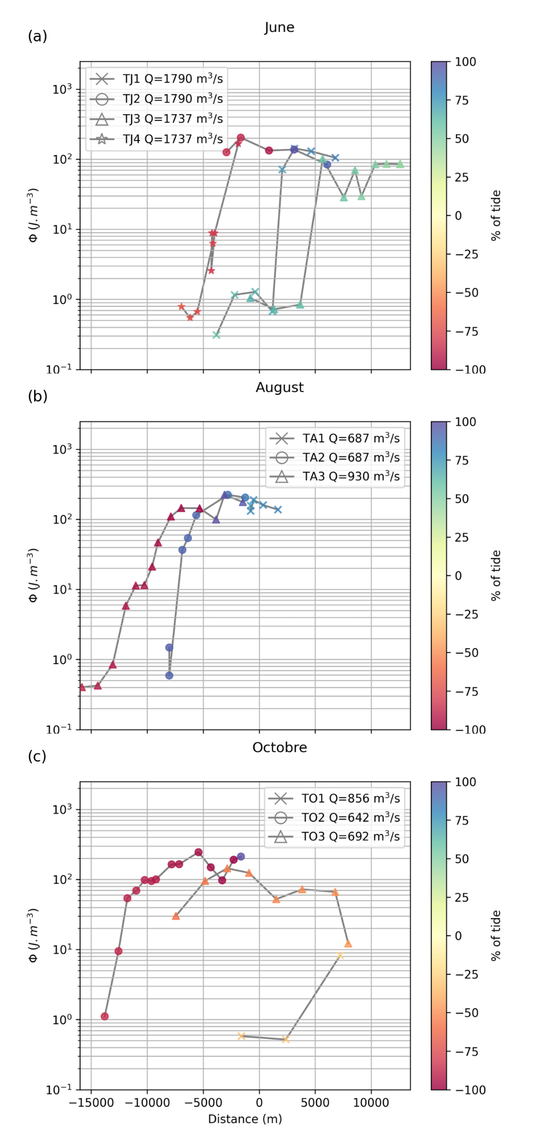

Figure 7: Simpson parameter (log scale) depending on the distance from the water mouth (a negative distance corresponds to a position upstream the mouth) for (a) June, (b) August and (c) October transects. Colors refer to the percentage of tide T%.

Fig. 6 shows the salinity sections along June TJ1 and August TA2 transects both performed between mid and late-flood (59 T% to 88 T% in June and 86 T% to 94 T% in August) with daily discharges of 1790 and 687 m³/s, respectively. Fig. 7 reports the evolution of the Simpson parameter along the transects, depicting the transition between a homogeneous freshwater column and a stratified water column.

Despite their similar tidal phase (both after mid-flood), the locations of the stratified waters differ between TJ1 and TA2 transects. While stratified columns are only observed downstream the mouth in June, the stratified zone is observed further upstream in August (from 7 km upstream of the mouth). A part of the change in the location can thus presumably be attributed to the discharge.

The June TJ1 transect is representative of rather- to well-mixed conditions (Fig. 6a) with a high discharge (Q=1790 m³/s). The water column shows homogeneous riverine water upstream (stations J1 to J4, 4 km upstream to 1 km offshore). The salinity then progressively increases to a fully salted but stratified water column (J10, 9 km offshore). The Simpson parameter (Fig. 7a, cross symbol) is high (>30 J/m³) and increases from 2 km (70 J/m³) to 5 km (150 J/m³) downstream, slightly decreasing further downstream after the maximum (100 J/m³) (corresponding to J5 to J7 on Fig. 6a).

The August TA2 transect (Fig. 6b), with a lower discharge (687 m³/s) shows stratified waters over most of the transect, with freshwater present in surface at each station (and over the whole column in A11), similar to the portion J1-J7 on TJ1. Stratification varies from homogeneous freshwater upstream (station A11, -8 km Simpson of 0.6-1.5 J/m³) to stratified column with freshwater on the surface and a slightly increasing salinity in the bottom layer downstream (A10 to A6, from -7km to 0km, maximum Simpson values ~200 J/m³ at A6 and A7). Note that waters off the river mouth were not sampled during this transect.

At mid-flood, the estuary is more stratified and the stratification rises higher in August, when the discharge is lower, than in June.

### Salinity intrusion

Table 3: Time, distance and daily mean discharge of the further downstream station where salinity < 0.9 PSU, corresponding, for transects, to the furthest downstream station (only those where it could be determined) or, for fixed stations, to the last measurement. For each survey, the most upstream and the most downstream stations with salinity > 0.9 PSU are indicated in bold.

|  |  |  |  |  |
| --- | --- | --- | --- | --- |
| Transect | Furthest downstream station where salinity < 0.9 PSU | T% | Distance to mouth (m) | Daily mean discharge (m3/s) |
| TJ1 | J4 | 70 | 1180 | 1790 |
| TJ3 | **J26** | 60 | **3660** | 1737 |
| TJ4 | **J35** | -78 | **-4130** | 1737 |
| FSJ | FJ24 | 81 | 0 | 1954 |
| TA2 | A11 | 94 | -6856 | 687 |
| TA3 | **A25** | -91 | **-13073** | 930 |
| FSA | **FA11** | 79 | **-800** | 1577 |
| TO1 | **O2** | -31 | **834** | 856 |
| TO2 | **O21** | -85 | -**13789** | 642 |
| TO4 | O31 | 78 | -6311 | 691 |
| TO5 | O33 | 92 | -3305 | 691 |
| FSO | FO48 | 71 | -1600 | 691 |

The limit of salt intrusion is deduced from the evolution of the Simpson parameter (Fig. 7), taking the position where it goes from values below 1 J/m³ (homogeneous column) to values about 10 J/m³ (stratified column).

The location of the freshwater-saltwater transition evolves with tidal phase: the further upstream salt waters are sampled at early ebb (-4.1 km at -70 T% in June, -13.1 km at -94 T% in June, -13.8 km at -78 T% in October). The further downstream ascents occur during late flood (at 60 T%, +3.6 km in June; 79 T%, -0.8 km in August) and late ebb (0.8 km, -31 T% in October; this period was not sampled in June and August).

In addition with tide, discharge also appears to be a main driver of the upper limit of salt intrusion. In June (the highest daily discharge, see Table 3), two out of three salt intrusions were located outside the riverine estuary, 1.2 km (78 T%) and 3.7 km (69 T%) off the river mouth. During the same tidal phase (~78 T%), the salt intrusion in August and October was located upstream the river mouth (respectively -0.8 km and Q=1577 m³/s at FSA and at -6.3 km and Q=697 m³/s at T04, Table 3).

Salinity intrusion is therefore driven jointly by tide and discharge. It is maximal in the beginning of the ebb and is enhanced for low discharges.

### Bathymetry

Analysis of the ADCP data in bottom track mode along the 13 transects during the three surveys shows a bathymetry that varies significantly along and across the estuary (transects not all shown).

Upstream of the mouth, there are significant lateral variations between the main channel (~10 m depth) and the banks (< 5 m). The main channel (generally in the middle of the river) is also punctuated by deeper pools, some of which are deeper than 15 m on the outside of the meanders (see e.g. Fig. 8b, J38).

The downstream estuary (downstream the fixed stations) is characterized by the presence of sandbars lining the main channel. The 7 (out of 12) transects that exit the river show a decrease in bottom depth from about 10 m at the mouth (see for example J16-J17 of TJ2, Fig. 8b) to less than 5 m offshore (see J13, Fig. 8b).

However, this bathymetry is itself bumpy: three transects (TJ3, TA1, TA4) are monotonously shallow passing from ~ 10 m upstream the mouth to 5-6 m further downstream, while others cross a shallower sandbank (~3 m) (TJ1 and TJ2, see for example Fig. 8b between J14 and J15 for TJ2). Sandbars thus cover this area, but not the entire width of the channel.

Satellite data provide additional observations on the Van Uc morphology (Fig. 9b). At low tide, the bay becomes a channel flowing between emerging sandbars, and the river mouth is located ~8 km further offshore (point LT Mouth on Fig. 8b). Thus, the position of the Van Uc mouth changes by several kilometers during the tidal cycle. This is consistent with salinity observations: measurements during TJ3 mid-tide June transect showed no stratification, i.e. no seawater, up to 4 km downstream the fixed station (Table 3 and Fig. 7a).

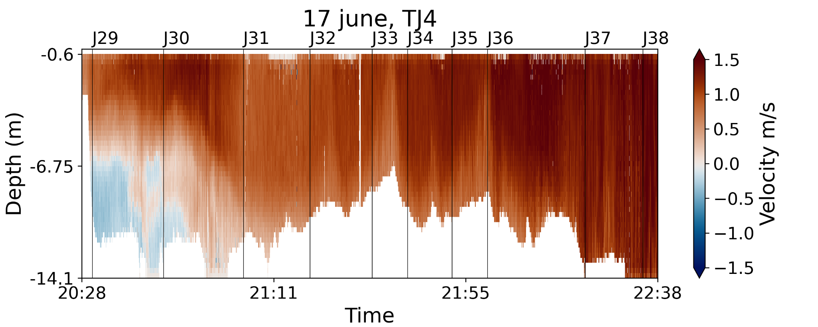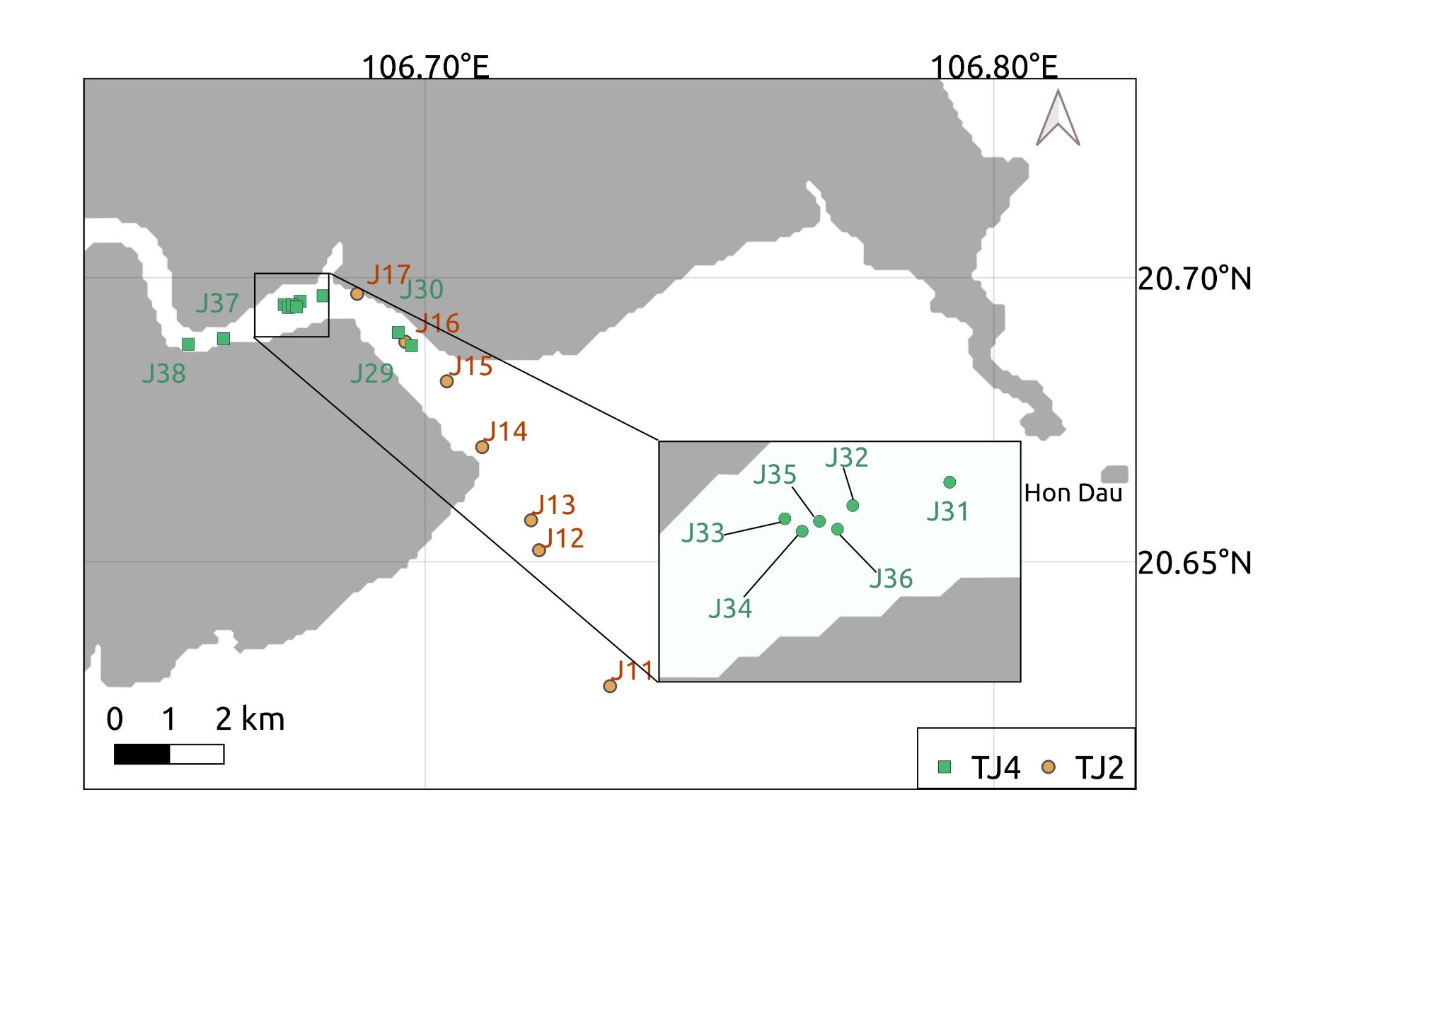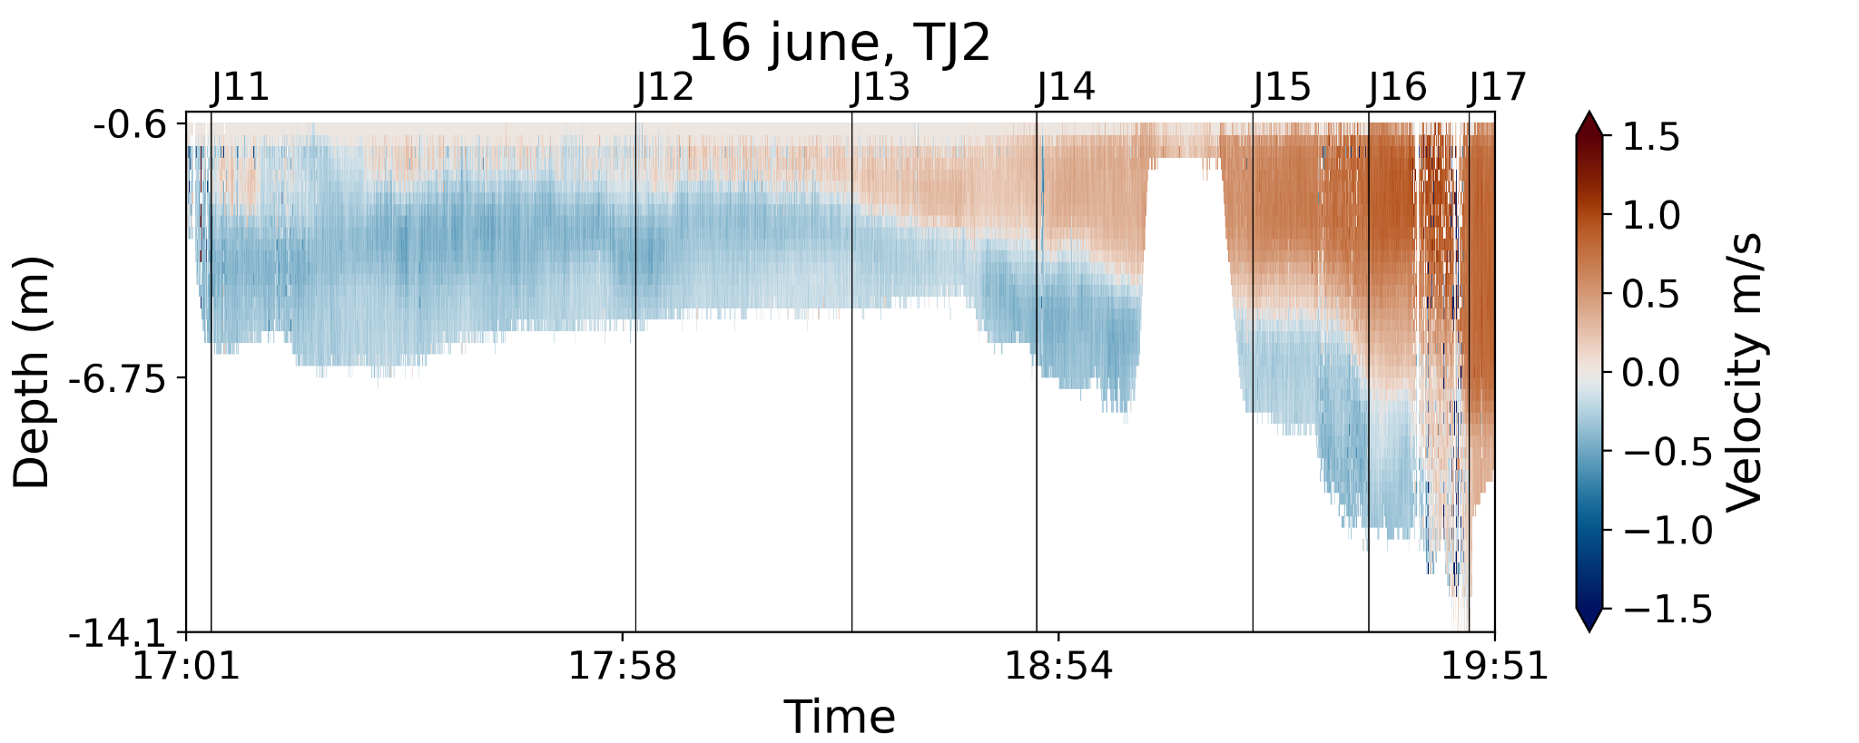

a)

b)

c)

OCEAN

LAND

OCEAN

LAND

Figure 8: Velocity for transects TJ2 (around high tide, 92 to -86 T%) (b) and TJ4 (around early ebb, from -88 to -70 T%) (c) and their location in the estuary (a)

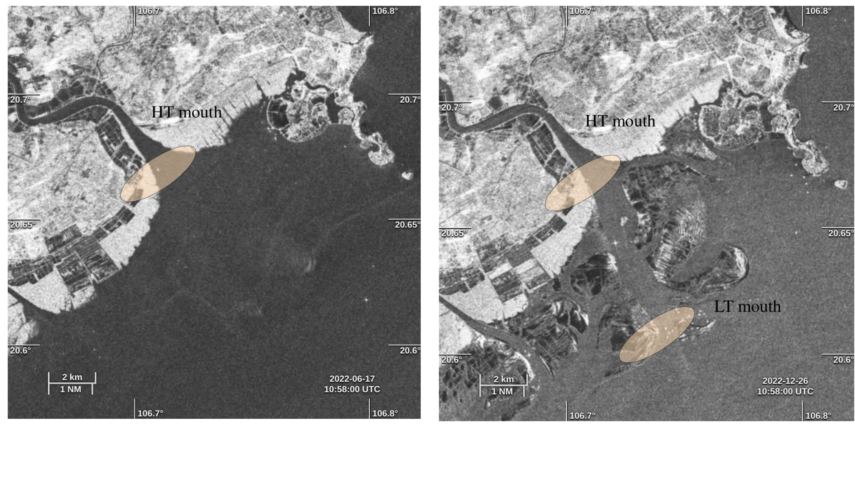

Figure 9: Sentinel-1 (SAR) images of the Van Uc estuary and coastal zone at a) high tide (Hon Dau sea level 3.98 m) on 17/06/2022 and (b) low tide (Hon Dau sea level 0.22 m) on 26/12/2022. Circled zone schematics the mouth(s) of the river.

### Current

The longitudinal velocity sections along a given transect illustrate the spatial variations of the current during a relatively homogeneous tidal phase. The chosen transects illustrate the nodal point, corresponding to the location with no velocity.

Transect TJ4 was conducted during the ebb tide (-88 to -72 T%, Fig. 8.c). Over 4.6 km and 16 T% (~2h), the structure of the water column changes from high outflow velocities (~1.5 m/s) homogeneous over the water column upstream (J37-J38, 1.2 m/s) to a bidirectional column downstream with an outflowing surface layer over an inflowing bottom layer (from J29 to J30, at ~-3km), passing through an intermediate zone where full depth outflow decreases (from J35 to J31). In the bidirectional part, the bottom layer thickens until the surface layer is only ~5 m thick over the ~12 m of the water column: the river plume is established, with a surface outflow ~1 m/s and a bottom inflow ~-0.2 m/s.

Transect TJ2 was conducted further downstream and around the high tide (92 to -86 T%, Fig. 8.b). This transect again describes the typical behavior of a river plume with outflow velocities over the whole water column in the upstream part (at J17 ~-3 km, with higher velocity in the surface layer ~0.6 m/s than in the bottom layer ~0.3 m/s), and a bidirectional flow further offshore, with velocity decreasing between J16 and J11 from 1 to 0 m/s, and a bottom saltwater inflow with velocity ~0.3 m/s. The river plume extends a lot, from the nodal point to J11 (~6 km downstream), and probably further offshore. Interestingly, a faster inflowing layer is observed in the center of the water column downstream of the mouth, after the sandbar (J11-J14 ~0.5 m/s vs ~0.3 m/s for the rest of the inflowing layer). This phenomenon occurs for situations with a bidirectional flow between mid-flood and high tide or even early ebb (see the example of TJ2 in Fig. 8.b, with velocity < 0.5 m/s between J11 and J14) but also for a unidirectional inflow (not shown). However, it does not occur during ebb for high velocities (> 1.2 m/s, see the example of TJ4 in Fig. 8.c).

The Van Uc estuary undergoes a bidirectional flux, i.e. an estuarine circulation. In june, both transect TJ2 and TJ4 nodal points are observed around -3 km (respectively around J17 and J30), corresponding to -86 T%, and for similar discharges. They show a typical high discharge situation: full depth outflowing water with very high velocities (~1.5 m/s) upstream the nodal point and a bidirectional flux settling from the nodal point to further offshore, leading to a plume structure further offshore.

# Discussion

## Morphological specificities of the Van Uc estuary: an ebb delta, supporting a tidal-moving mouth

The Van Uc nearshore area is very shallow (<10m) with several sandbanks lining the main channel, whose depth is a few meters. At high tide, water is present everywhere, covering the sandbanks. The river flow is channelized down to the high tide river mouth (point HT mouth on Fig. 9a) and generates a river plume from this point. At low tide, the sandbanks emerge, water is only flowing in the main channel and the connection between riverine and marine waters, i.e. the mouth, is located further downstream (point LT mouth, Fig. 9b).

This specific morphology supports a tidal-moving river mouth, with a typical morphology of ebb-tidal deltas, formed by sediment deposited by ebb-tidal currents off the river mouth, and modified by waves (Galloway, 1975; Hayes, 1980; Hayes and Fitzgerald, 2013). Examples of ebb-tidal deltas are numerous on the eastern coast of the U.S. in South Carolina (Finley, 1975, 1978; FitzGerald, 1977) and Massachusetts (Hubbard, 1975, 1977), along the southwestern part of the Netherlands (van Leeuwen et al 2003, Elias and Van Der Speek 2006, van der Vegt, 2009) or in France in the Orne delta (Le Bas and Levoy, 2018). Large tidal amplitude together with small wave height moreover favor the extension of ebb-tidal delta (Hayes, 1980), explaining the relatively large spatial extension of the Van Uc ebb-tidal delta.

Ebb-tidal deltas have several common characteristics described in Hayes (1980), in particular a main ebb channel, a channel-margin bars lining the main channel, a terminal lobe located at the end of the ebb channel and swash platforms on both sides of the channel (Fig. 9b). Generally, the ebb-tidal delta’s main channel is characterized by a slight-to-strong dominance of ebb-tidal currents over flood-tidal currents in terms of velocity value plus the fact that maximum velocity do not occur at mid-tide, but later, near low tide (Postma 1967). In the case of the Van Uc, the present measurements showed that ebb-tidal current last about twice the time of the flood-tidal currents at the mouth fixed stations (section 4.1.1). Also, the ebb velocities were stronger than the flood velocities. However, those measurements were undertaken under high river discharge, and, therefore, do not reveal the functioning of the Van Uc under classical conditions and need to be taken with caution. The maximum velocities were found to occur around mid-ebb, and not near low tide. We remind that the measurement were made at the mouth, and not in the main ebb channel. More measurements should be taken in order to deepen the knowledge of the ebb-tidal delta characteristics, and to observe the spatial variability within this complex structure.

## Evolution of the estuary partition with discharge and tide

Dionne (1963) and Fairbridge (1980) split an estuary in three zones: the upper or riverine estuary dynamically influenced by tide, the middle estuary corresponding to the limit of salt intrusion, and the lower or marine estuary. Their boundaries move with discharge. In regard to its ebb-delta configuration, the Van Uc lower estuary configuration also varies with tides, shifted downstream at low tide and for high river discharge. As a consequence, the position of the middle estuary also varies. This is shown by the very variable upstream limits of salt intrusion described in section 4.3.2, varying from 13 km upstream to 4 km downstream depending on the discharge.

During Piton et al. (2020) wet season survey conducted at spring tide in August-September 2017, the discharge (Q=2238 m³/s) was intense, like in June 2022 discharges, but the tidal range was smaller (2.4 m vs. 3.0 to 4.0 m, Table 1). As a consequence, saltwater did not penetrate the estuary in 2017, while we observed salt in the estuary in June 2022 (at FSJ and up to 4 km upstream the mouth, TJ4, Table 3). This confirms that salt intrusion and more generally the Van Uc estuarine dynamics is very sensitive to the tidal range, and that the middle estuary limit strongly depends both on discharge and tide.

We did not identify the upstream limit of the upper estuary, however TT’s water level is always influenced by tides. This suggests that this limit is located between Ha Noi and TT. It probably moves with discharge and tides, since we highlighted a tidal damping varying with discharges in a previous study (Pénicaud et al submitted).

## Hydrodynamics of the estuary

### Current reversal

At the Van Uc mouth, the current reversal from ebb to flood occurs first in the bottom, while the reversal from flood to ebb occurs simultaneously throughout the water column. Once the current reversal is settled between mid and late flood (54-71 T%, Table 2), the salinity enters the estuary between late flood and high tide (75-80 T%, Table 2). The Mekong River current reversal shows a similar behavior for similar conditions: in wet season, at spring tides, its water columns is very stratified, with an ephemeral salt wedge moving with tides, appearing near the mouth from late flood to early ebb, then slowly vanishing during the ebb tide, while the maximum salinity is reached at the end of flood (Wolanski et al., 1996; Nowacki et al., 2015). In the Van Uc, a similar stratification is observed during the salt wedge presence, but salinity reaches the surface in August and October fixed station (Fig. 3b and c).

### Salinity intrusion

Because the surveys occurred during three different ranges of water discharge (from 600 to 1900 m³/s, see Table 1), we observed a large range of salt intrusion in the Van Uc estuary, from 5 km to 13 km upstream the mouth. Pham, (2004) reported a longer salinity intrusion maximum over the year for other tributaries of the Red River: up to 40 km upstream for the Cua Cam, 38 km for the Lach Tray, 28 km for the Thai Binh and 20 km for the Ba Lat. The values reported here for the Van Uc are lower because the sampling occurred during the wet season and higher discharges reduce the salt propagation. The 13 km maximum value is therefore only informative of the maximum length of salinity intrusion in the high range of discharge (>600 m³/s).

A similar sensitivity of salt intrusion to discharge for comparable tides was observed and quantified in other estuaries. During the high flow season, the Mekong has an ephemeral salt wedge confined to the river mouth (from 10 km to 30 km upstream the mouth), whereas for similar spring tides but in the low flow season, the salt intrusion propagates up to 50 km upstream and the Mekong estuary is partially mixed (Wolanski et al., 1998, Nguyen and Tanaka, 2007a&b; Nguyen et al., 2008; Nowacki et al., 2015). The same transition between a high flow-high stratification and a low flow-partially mixed estuary is observed in other estuaries: the Columbia (USA, Hughes and Rattray, 1980), Tamar (UK, Bale et al., 1985) and Merrimack (USA, Ralston et al., 2010).

Maximum salinity intrusions were moreover only estimated here for early ebb (Table 3 and Fig. 7), and, except for TO1, no transects were performed at mid-ebb or late ebb. The sampled positions of salt intrusion from transects do therefore not reflect the full tidal cycle. Assuming that salinity propagates with velocity, one can however estimate the salt intrusion from fixed stations measurements that covered the whole tidal cycle. For that, we integrate the velocity between the time of first non-zero salinity and the time of high water slack. For June and August fixed stations (Q>1500 m³/s), the duration between salinity entrance to high water slack (null velocity) at the mouth is 2 h (Fig. 3.a and b), and the mean velocity during this phase is -0.5 m/s, giving an intrusion length of 3.6 km. This value is in agreement with the one found in TJ4 transect in June at early ebb (4.1 km) for similar discharge conditions (1737 m³/s). For the other range of discharge (<1000 m³/s), the October station data could be used, but no continuous data is available between the first non-zero salinity and the following slack water. However, one can observe the value quite perfectly match when looping the data (last salinity and the first one, Fig. 3.c), and the discharge between the two days do not vary much. The duration between the first non-zero salinity and the slack water (in the bottom layer) estimated is 5 h with a mean velocity about 0.7 m/s, giving an intrusion of 12.6 km, corresponding to the values sampled in this range of discharge in early ebb (TA3 at 13.1 km for 930 m³/s, TO2 at -13.8 km for 642 m³/s). This suggests that the salinity intrusion estimated from our transects performed at late flood to early ebb is therefore representative of the saline intrusion length over the whole tidal cycle, and that the 5-13 km range captures the range of saline intrusion variation.

Those measurements will be useful to the validation of a high spatial and temporal resolution model, that will help in estimating the salinity intrusion along the year with various discharge and tidal situations. That could therefore be a tool in analyzing the risks for the local rice crops and agriculture, for freshwater pumping for domestic use or for the local ecosystems.

### Current - salinity lag

The current reversal is more sensitive to the discharge than the salinity arrival. At the fixed station, a higher discharge decreases the delay between the reversal from outflow to inflow and the salinity arrival: this delay increases from 9 to 21 T% (i.e. 1 h to 2h45) between June and October, for discharges decreasing from 1954 to 691 m³/s (Table 2). As the salinity did not show strong sensitivity to the discharge, this delay is due to the current reversal high sensitivity to discharge.

### Stratification

Estuarine stratification depends on water discharge and tides (Savenije, 2005). Our surveys aimed at quantifying the impact of river discharge and tidal cycle at spring tides in the Van Uc river. Different stratification structures, from salt wedge to partially mixed waters, were found over the tidal cycle and for different discharge ranges. In the Van Uc, as in the neighboring Cam river (Lefebvre et al., 2012), the stratification increases from mid-flood to high tide (maximal), then decreased quickly at ebb tide (Fig. 7).

The river discharge impact was analyzed. Higher river discharge pushes the limit of the salt intrusion downstream, increases the estuarine circulation and increases stratification downstream. Lefebvre et al. (2012) similarly observed a much higher stratification for the low discharge than for high river discharge (even tough it was at a seasonal scale) in the neighboring Cam river. Piton et al., (2020) indeed showed that the Van Uc estuary goes from highly stratified in neap tide, to partially mixed in spring tide.

# Conclusion

The Van Uc estuary was studied under spatial and temporal high frequency during the wet season from in situ measurements in order to have a better understanding of its hydrodynamics behaviour. This study aimed at providing a better description and understanding of the Van Uc estuary, one of the main branches of the Red River, hydrodynamical functioning, quantifying in particular the influence of river discharge on the estuary dynamics. For that, three surveys performed at spring-tide for different discharge conditions of the wet season 2022 (June, August, September) provided a new set of measurements that enriches the previous and unique surveys made in the wet (August, September) and dry (December) seasons of 2017 (Piton et al., 2020). In particular, the wet season was targeted for its highly variable in a wide range of riverine discharge, due to a tropical climate.

Under spring tides and relatively high river discharge, the Van Uc estuary experienced an exchange flow, and a salt wedge, going from homogeneous fresh water column to stratified conditions, depending on the tidal phase. During the wet season, at the river mouth, the current reversal from out to inflow occurs at mid-flood. Saltwaters enter the estuary after the reversal, in the late flood tide near high tide, and are firstly confined in the bottom layer. Salinity develop in the water column, reaching the surface near the mouth, but still conserving a strong stratification. A partially-mixed to stratified estuary is found in the three field surveys. Those measurements allowed to follow the salt intrusion, that was found maximum at early ebb.

The field surveys also revealed that the estuary dynamics, at equivalent tidal conditions, is highly sensitive to the river discharge. First, a current direction sensitivity was showed, with flood currents at the entrance that can be reduced to last less than 20% of the ebb currents duration. Second, for the similar tidal conditions studied here, this salt intrusion is highly dependent on the discharge: the higher the discharge, the further downstream the limit of salt intrusion. The stratification variations also depend on the discharge: higher discharge leads to a shorter extent of the stratified region. Comparison between velocity and salinity data revealed that the velocity reversal temporality is more impacted than the salt intrusion by the discharge. Higher discharges delay the current reversal by several hours, but not significantly the salinity entrance.

While microtidal estuaries are mainly driven by the estuarine circulation, macrotidal estuaries are driven by the tide-induced mixing. River discharge, in general the highly non-linear variable of the system, plays a significant role in the circulation and mixing of an estuary. In a tropical estuary with very high seasonal and intraseasonal variations, those variations are of particular interest, reaching extreme values during heavy rainfall events, such as those caused by tropical storms and cyclones. With a mesotidal regime and a tropical weather conditions that include regular intense river discharge conditions, the Van Uc River is jointly and alternatively driven by river discharge and tide.

The analysis of the hydrodynamics studied here is a necessary work to better understand the behaviour of this estuary. Previous work showed that the tidal propagation was impacted by both river discharge and tides, that could increase the tidal asymmetry found in the estuary as well as the damping of the tidal amplitude. The impact of river discharge is expected to contribute to sediment transport change. Also, tidal asymmetry plus gravitational circulation and tidal pumping can be the cause of an estuarine turbidity maxima (Van Maren and Gerritsen, 2012; Hoitink et al., 2003), as in the next Cam river estuary (Vinh and Ouillon, 2021). Future work will consist in studying the impact of the hydrodynamics on the sediment transport, from data measurements as well as from coupled high resolution modelling.

In the meantime, major works have been carried out in the area to expand the port of Hai Phong, which promise far-reaching changes that are likely to affect the dynamics of the area. This benchmark of data will therefore be useful to document the changes caused by these anthropic facilities.

# Declaration of competing interest

The authors declare no conflict of interest.

# Acknowledgments

This study has been partially supported through the grant EUR TESS N°ANR-18-EURE-0018 in the framework of the Programme des Investissements d'Avenir. This paper is a contribution to the LOTUS International Joint Laboratory (lotus.usth.edu.vn). The authors warmly thank XXXX for their precious work and help during the field campaigns, as well as the boat crew.

# Author contribution

JP, SO and MH conceived the study. JP, VDV, and SO organized the field trip, JP, VDV, SO and MH performed the measurements. JP analyzed the data under supervision of SO and MH. JP, MH, SO and FT prepared the manuscript.

# References

Allen, G. P., Salomon, J. C., Bassoullet, P., Du Penhoat, Y., & De Grandpré, C. (1980). Effects of tides on mixing and suspended sediment transport in macrotidal estuaries. *Sedimentary Geology*, *26*(1–3), 69–90.<https://doi.org/10.1016/0037-0738(80)90006-8>

Bale, A. J., Morris, A. W., & Howland, R. J. M. (1985). Seasonal sediment movement in the Tamar Estuary. *Oceanologica Acta*, *8*(1), 1–6.

Boyd, R., Dalrymple, R., & Zaitlin, B. A. (1992). Classification of clastic coastal depositional environments. *Sedimentary Geology*, *80*(3–4), 139–150.

Cai, H., Savenije, H. H., Zuo, S., Jiang, C., & Chua, V. P. (2015). A predictive model for salt intrusion in estuaries applied to the Yangtze estuary. *Journal of Hydrology*, *529*, 1336–1349.

Dalrymple, R. W., Zaitlin, B. A., & Boyd, R. (1992). Estuarine facies models; conceptual basis and stratigraphic implications. *Journal of Sedimentary Research*, *62*(6), 1130–1146.

Dang, T. H., Coynel, A., Orange, D., Blanc, G., Etcheber, H., & Le, L. A. (2010). Long-term monitoring (1960–2008) of the river-sediment transport in the Red River Watershed (Vietnam): Temporal variability and dam-reservoir impact. *Science of The Total Environment*, *408*(20), 4654–4664.<https://doi.org/10.1016/j.scitotenv.2010.07.007>

Dionne, J.-C. (1963). I. Définition du terme d’Estuaire 2. *Annales de Géomorphologie*, *7*, 36.

Eisma, D. (1993). Transport Systems and Fluxes of Suspended Matter. In D. Eisma, *Suspended Matter in the Aquatic Environment* (pp. 167–263). Springer Berlin Heidelberg.<https://doi.org/10.1007/978-3-642-77722-6_7>

Elias, Edwin P.L., and Ad J.F. Van Der Spek. 2006. “Long-Term Morphodynamic Evolution of Texel Inlet and Its Ebb-Tidal Delta (The Netherlands).” *Marine Geology* 225 (1–4): 5–21.<https://doi.org/10.1016/j.margeo.2005.09.008>.

Fairbridge, R. W. (1980). The estuary: Its definition and geodynamic cycle. *Chemistry and Biochemistry of Estuaries*, 1–35.

Finley, R. J. (1975). Hydrodynamics and tidal deltas of North Inlet, South Carolina. In *Geology and Engineering* (pp. 277–291). Elsevier.<https://www.sciencedirect.com/science/article/pii/B9780121975029500228>

Finley, R. J. (1978). Ebb-tidal delta morphology and sediment supply in relation to seasonal wave energy flux, North Inlet, South Carolina. *Journal of Sedimentary Research*, *48*(1), 227–238.

FitzGerald, D. M. (1977). Ebb-tidal delta stratification. *Beaches and Barriers of the Central South Carolina Coast Fieldtrip Guidebook for Coastal Zone, 1977, Coastal Engineering Conference*.<https://cir.nii.ac.jp/crid/1570291225352099200>

Fry, V. A., & Aubrey, D. G. (1990). Tidal velocity asymmetries and bedload transport in shallow embayments. *Estuarine, Coastal and Shelf Science*, *30*(5), 453–473.

Galloway, W. E. (1975). *Process framework for describing the morphologic and stratigraphic evolution of deltaic depositional systems*.<https://archives.datapages.com/data/hgssp/data/022/022001/87_hgs0220087.htm>

Guo, L., Van Der Wegen, M., Jay, D. A., Matte, P., Wang, Z. B., Roelvink, D., & He, Q. (2015). River‐tide dynamics: Exploration of nonstationary and nonlinear tidal behavior in the Yangtze River estuary. *Journal of Geophysical Research: Oceans*, *120*(5), 3499–3521.<https://doi.org/10.1002/2014JC010491>

Guo, L., Wang, Z. B., Townend, I., & He, Q. (2019). Quantification of Tidal Asymmetry and Its Nonstationary Variations. *Journal of Geophysical Research: Oceans*, *124*(1), 773–787.<https://doi.org/10.1029/2018JC014372>

Hayes, M. O. (1980). General morphology and sediment patterns in tidal inlets. *Sedimentary Geology*, *26*(1–3), 139–156. https://doi.org/10.1016/0037-0738(80)90009-3

Hayes, M. O., & FitzGerald, D. M. (2013). Origin, evolution, and classification of tidal inlets. *Journal of Coastal Research*, *69*, 14–33. https://doi.org/10.2112/SI_69_3

Hoitink, A. J. F., Hoekstra, P., & Van Maren, D. S. (2003). Flow asymmetry associated with astronomical tides: Implications for the residual transport of sediment. *Journal of Geophysical Research: Oceans*, *108*(C10), 2002JC001539.<https://doi.org/10.1029/2002JC001539>

Hubbard, D. K. (1975). Morphology and hydrodynamics of the Merrimack River ebb-tidal delta. In *Geology and Engineering* (pp. 253–266). Elsevier.<https://www.sciencedirect.com/science/article/pii/B9780121975029500204>

Hubbard, D. K., MO, H., JH, B., & GF, O. (1977). *DISTRIBUTION OF SEDIMENTARY STRUCTURES IN EBB-TIDAL DELTA SEDIMENTS.*<https://pascal-francis.inist.fr/vibad/index.php?action=getRecordDetail&idt=PASCALGEODEBRGM7820182520>

Hughes, F. W., & Rattray Jr, M. (1980). Salt flux and mixing in the Columbia River Estuary. *Estuarine and Coastal Marine Science*, *10*(5), 479–493. https://doi.org/10.1016/S0302-3524(80)80070-3

Jay, D. A., Leffler, K., & Degens, S. (2011). Long-Term Evolution of Columbia River Tides. *Journal of Waterway, Port, Coastal, and Ocean Engineering*, *137*(4), 182–191.<https://doi.org/10.1061/(ASCE)WW.1943-5460.0000082>

Kukulka, T., & Jay, D. A. (2003a). Impacts of Columbia River discharge on salmonid habitat: 1. A nonstationary fluvial tide model. *Journal of Geophysical Research: Oceans*, *108*(C9), 2002JC001382.<https://doi.org/10.1029/2002JC001382>

Kukulka, T., & Jay, D. A. (2003b). Impacts of Columbia River discharge on salmonid habitat: 2. Changes in shallow‐water habitat. *Journal of Geophysical Research: Oceans*, *108*(C9), 2003JC001829.<https://doi.org/10.1029/2003JC001829>

Le Bas, X. P., & Levoy, F. (2018). Bar migrations on a macrotidal Ebb Delta over a period of six years using Lidar survey. *Journal of Coastal Research*, *85*, 146–150. : https://doi.org/10.2112/SI85-030.1

Le, T. P. Q., Garnier, J., Gilles, B., Sylvain, T., & Van Minh, C. (2007). The changing flow regime and sediment load of the Red River, Viet Nam. *Journal of Hydrology*, *334*(1–2), 199–214.<https://doi.org/10.1016/j.jhydrol.2006.10.020>

Lefebvre, J.-P., Ouillon, S., Vinh, V. D., Arfi, R., Panché, J.-Y., Mari, X., Van Thuoc, C., & Torréton, J.-P. (2012). Seasonal variability of cohesive sediment aggregation in the Bach Dang–Cam Estuary, Haiphong (Vietnam). *Geo-Marine Letters*, *32*, 103–121. <https://doi.org/10.1007/s00367-011-0273-8>

Meybeck, M. (1993). Riverine transport of atmospheric carbon: Sources, global typology and budget. *Water, Air, and Soil Pollution*, *70*, 443–463.

Milliman, J. D. (1991). Flux and fate of fluvial sediment and water in coastal seas. *Ocean Margin Processes in Global Change*, 69–89.

Milliman, J. D. (1995). River discharge to the sea: A global river index (GLORI). *LOICZ Reports and Studies*, *2*.<https://cir.nii.ac.jp/crid/1573387449944080512>

Minh, N. N., Marchesiello P., Lyard F., Ouillon S., Cambon G., Allain D., Uu D.V., 2014. Tidal characteristics of the Gulf of Tonkin, *Continental Shelf Research*, 91, 37-56. <https://doi.org/10.1016/j.csr.2014.08.003>

Nguyen, A. D., Savenije, H. H., Pham, D. N., & Tang, D. T. (2008). Using salt intrusion measurements to determine the freshwater discharge distribution over the branches of a multi-channel estuary: The Mekong Delta case. *Estuarine, Coastal and Shelf Science*, *77*(3), 433–445.

Nguyen, T. V., & Tanaka, H. (2007a). Study on the effect of morphology change on salinity distribution in the Dinh An estuary, lower Mekong River of Vietnam. *Journal of Coastal Research*, 268–272.

Nguyen, T. V., & Tanaka, H. (2007b). Study on the effect of morphology change on salinity distribution in the Dinh An estuary, lower Mekong River of Vietnam. *Journal of Coastal Research*, 268–272.

Nowacki, D. J., Ogston, A. S., Nittrouer, C. A., Fricke, A. T., & Van, P. D. T. (2015). Sediment dynamics in the lower M ekong R iver: Transition from tidal river to estuary. *Journal of Geophysical Research: Oceans*, *120*(9), 6363–6383.<https://doi.org/10.1002/2015JC010754>

Pham, Q. S. 2004. “Study of Development of Red River: That Binh River Estuaries on the Basis of Remote Sensing’s Information and GIS for Rational Exploitation of Use of Territory.” PhD Thesis, PhD Thesis, National University, Vietnam, p 155.

Piton, V., Ouillon, S., Vinh, V. D., Many, G., Herrmann, M., & Marsaleix, P. (2020). Seasonal and tidal variability of the hydrology and suspended particulate matter in the Van Uc estuary, Red River, Vietnam. *Journal of Marine Systems*, *211*, 103403.<https://doi.org/10.1016/j.jmarsys.2020.103403>

Postma, H. (1988). Physical Processes in Estuaries; Some Evaluating Remarks. In J. Dronkers & W. Van Leussen (Eds.), *Physical Processes in Estuaries* (pp. 547–551). Springer Berlin Heidelberg.<https://doi.org/10.1007/978-3-642-73691-9_27>

Ralston, D. K., Geyer, W. R., & Lerczak, J. A. (2010). Structure, variability, and salt flux in a strongly forced salt wedge estuary. *Journal of Geophysical Research: Oceans*, *115*(C6), 2009JC005806.<https://doi.org/10.1029/2009JC005806>

Savenije, H. H. G. (1994). *Rapid assessment technique for salt intrusion in alluvial estuaries.*<https://elibrary.ru/item.asp?id=6858547>

Savenije, H. H. G. (2005). *Salinity and tides in alluvial estuaries* (1. ed). Elsevier.

Syvitski, J. P., Kettner, A. J., Overeem, I., Hutton, E. W., Hannon, M. T., Brakenridge, G. R., Day, J., Vörösmarty, C., Saito, Y., & Giosan, L. (2009). Sinking deltas due to human activities. *Nature Geoscience*, *2*(10), 681–686.

Leeuwen, S. M. van, M. van der Vegt, and H. E. de Swart. 2003. “Morphodynamics of Ebb-Tidal Deltas: A Model Approach.” *Estuarine, Coastal and Shelf Science* 57 (5): 899–907.<https://doi.org/10.1016/S0272-7714(02)00420-1>.

Van Der Vegt, M., H.M. Schuttelaars, and H.E. De Swart. 2009. “The Influence of Tidal Currents on the Asymmetry of Tide-Dominated Ebb–Tidal Deltas.” *Continental Shelf Research* 29 (1): 159–74.<https://doi.org/10.1016/j.csr.2008.01.018>.

van Maanen, B., & Sottolichio, A. (2018). Hydro-and sediment dynamics in the Gironde estuary (France): Sensitivity to seasonal variations in river inflow and sea level rise. *Continental Shelf Research*, *165*, 37–50.

Van Maren, D. S., & Gerritsen, H. (2012). Residual flow and tidal asymmetry in the Singapore Strait, with implications for resuspension and residual transport of sediment. *Journal of Geophysical Research: Oceans*, *117*(C4), 2011JC007615.<https://doi.org/10.1029/2011JC007615>

Vinh, V. D., & Ouillon, S. (2021). The double structure of the Estuarine Turbidity Maximum in the Cam-Nam Trieu mesotidal tropical estuary, Vietnam. *Marine Geology*, *442*, 106670. <https://doi.org/10.1016/j.margeo.2021.106670>

Vinh, V. D., Ouillon, S., Thanh, T. D., & Chu, L. V. (2014). Impact of the Hoa Binh dam (Vietnam) on water and sediment budgets in the Red River basin and delta. *Hydrology and Earth System Sciences*, *18*(10), 3987–4005.<https://doi.org/10.5194/hess-18-3987-2014>

Wolanski, E., Huan, N. N., Nhan, N. H., & Thuy, N. N. (1996). Fine-sediment dynamics in the Mekong River estuary, Vietnam. *Estuarine, Coastal and Shelf Science*, *43*(5), 565–582.

Wolanski, E., Nhan, N. H., & Spagnol, S. (1998). Sediment dynamics during low flow conditions in the Mekong River estuary, Vietnam. *Journal of Coastal Research*, 472–482.

Xie, D., Wang, Z. B., Huang, J., & Zeng, J. (2022). River, tide and morphology interaction in a macro-tidal estuary with active morphological evolutions. *Catena*, *212*, 106131.

Zhang, F., Sun, J., Lin, B., & Huang, G. (2018). Seasonal hydrodynamic interactions between tidal waves and river flows in the Yangtze Estuary. *Journal of Marine Systems*, *186*, 17–28.

Zu, T., Gan, J., & Erofeeva, S. Y. (2008). Numerical study of the tide and tidal dynamics in the South China Sea. *Deep Sea Research Part I: Oceanographic Research Papers*, *55*(2), 137–154.